|  |  |  |  |
| --- | --- | --- | --- |
| 1**SMC lets off steam with new fluid control valve** | |  | |
|  | | | | |
| SMC, the world’s leading manufacturer of pneumatics equipment, has upgraded its fluid control valve range with the launch of its new upgraded VXS Series. Designed to work with steam and heated water, the zero differential pressure type VXS series has new design features, making it more reliable and wear resistant.  With no fluid pressure required to operate the valve, it offers minimal air leakage thanks to a piston main valve and a rubber seal made from a special type of FKM, improving overall reliability. The VXS’ service life has also been extended thanks to its construction, which means the valve can perform 3 million cycles. And with double guide rings, the VXS delivers both a constant sliding movement performance and improved scraper function that minimizes the amount of foreign particles entering the valve, enhancing the resistance to contamination.  Following a review of the VXS’ magnetic coil circuit, this upgrade saves power and is environmentally friendly to operate. A rubber buffer and has flame resistant mold coil material keep it quiet as well. All this is part of SMC’s commitment to refine the performance and functionality of its products and enhance competitive advantages for customers. With both brass and stainless steel body options, the VXS is ideal for a wide range of applications including sterilization, heating and pressing processes within various sectors such as the Food, Medical, Textile, Process and General Industries.  Available with piping thread variations of ¼" to 1", class H solenoid type and an oil free option, the VXS is certainly a versatile addition to the SMC 2 port solenoid valve family. Recognized as a global technology leader and voted for the third consecutive year as one of the world’s most innovative company by leading business magazine, Forbes, SMC has a diverse customer base covering all automation industries. For more information about the VXS Series.  Please visit SMC’s New Product Section at www.smcin.com. | |  | | |

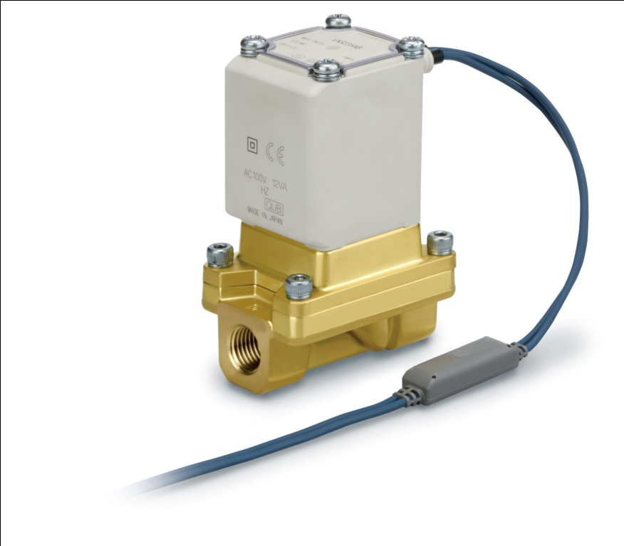

|  |  |
| --- | --- |
| 2**SMC provides the gentle touch with new non-contact gripper** |  |
|  | | |
| SMC, the world´s leading provider of pneumatics, has proved that it has got the gentle touch  when meeting market demand for a non-contact transfer. The innovative company has launched the highly flexible XT661, a vacuum operated mark-free gripper that can transfer a range of work pieces with differing sizes, forms, height and materials, with minimal and gentle contact. Available in two types, using the working principles Cyclone and Bernoulli, the XT661 comes in a range of sizes from Ø20mm up to Ø50mm. The Cyclone, gets its name from the way the air is discharged in a whirling direction. With a groove-channel design, it has a large suction area with even pressure dispersion and a high lifting force with low air consumption, making it economical to operate. It is also compact and lightweight, with a low profile Cyclone type that can be placed in robot arms for transfer. Alternatively, the Bernoulli discharges air radially which means there is minimal vibration during the gripping process, removing the need for a positioning guide. It also features a standardized multi-port allowing for easy detection of work pieces by connecting a sensor. The XT661 is easy to assemble, install and maintain as it´s grease-free and simple to disassemble and clean internally. It´s suitable for a range of applications that require fragile handling such as electronic circuit boards, solar battery cells, liquid crystal glass, insulating sheets, silicon wafers, electrode materials and copper film. Recognized as a global technology leader and voted for the third consecutive year as one of the world´s most innovative company by leading business magazine, Forbes, SMC has a diverse customer base covering all automation industries. For more information about the XT661, please visit SMC´s New Product Section |  |  |
|  | | |

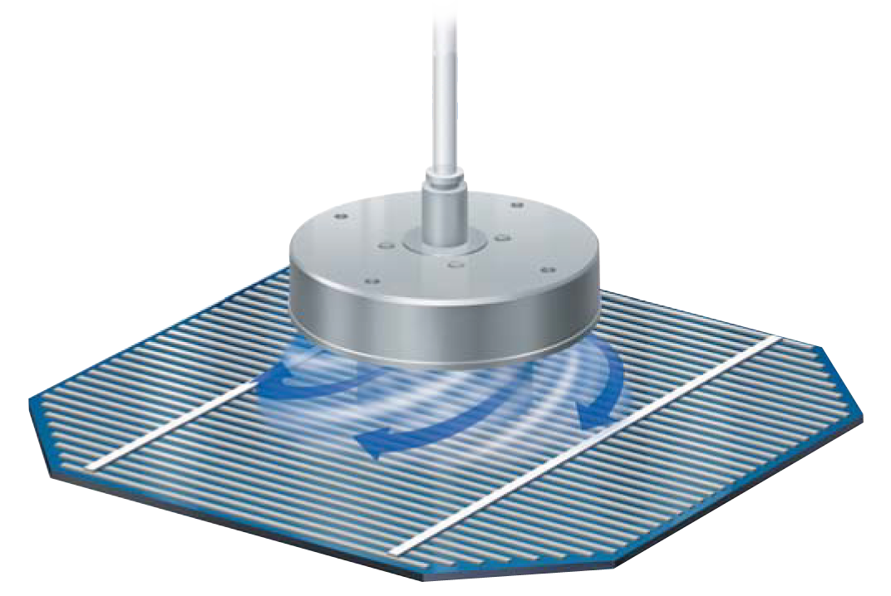

3**New compact electric actuator brings big benefits to SMC customers**

SMC, the world’s leading provider of pneumatics, has unveiled a low profile, guide slider electric actuator which offers a multitude of benefits. The LEM Series will last up to three times than the previous E-MY2 model thanks to a newly designed belt and bearings, which reduces maintenance and production costs and improves productivity. Using an offset construction, mounting the belt is easier and the connection between the separable drive unit and guide has also been improved. With a compact design, the LEM Series has a low profile and low centre of gravity due to a reduced table height, making it ideal for narrow spaces. This efficient design avoids interferences with the motor even when using large work pieces. The mounting dimensions are also interchangeable with the E-MY2 Series. The LEM Series is available in two different sizes with four guide types and the motor has four mounting options. Further productivity is increased thanks to reduced cycle times, with achievable speeds of 2000mm/s and acceleration/deceleration up to 20,000mm/s² with the step motor. Similar to the LE electric actuator series the new LEM is also compatible with SMC’s range of controllers including the step data input type, LECP6 and the programme free, LECP1. There is also the option of using the field bus protocols with a Gateway unit and the new LECP2, a programme free controller comprising stroke study function. With all these features, the LEM Series is ideal for all general industrial machinery in transfer and assembly related industries requiring precise positioning of work pieces, pick and place, load and unload transfer of work pieces to name just a few. Recognized as a global technology leader and recently voted for the third consecutive year as one of the world’s most innovative company by leading business magazine, Forbes, SMC has a diverse customer base covering all automation industries. For more information about the LEM Series, please visit SMC’s New Product Section at www.smcin.com

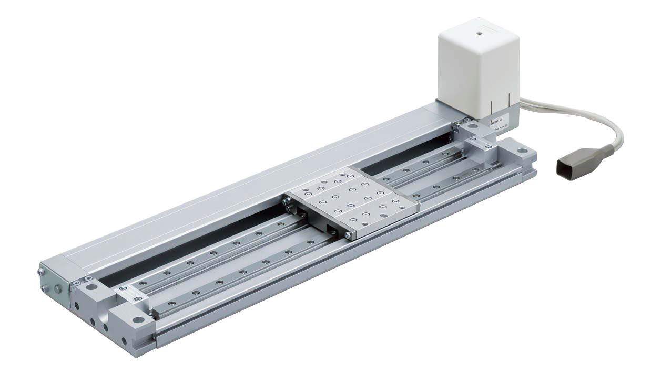

**4) High rigidity and large loads catered for in SMC's new LEJ series**

SMC continues to expand its popular electric actuator range by extending the options available for larger loads as well as driving mechanical excellence, with the launch of its LEJ Series. Designed with a double axis linear guide, the LEJ delivers high rigidity and optimum precision performance. The LEJ also offers space savings, due to its low profile and low centre of gravity construction, reducing the total height and weight by up to 36% and 37% respectively when compared to the LJ1 Series. Its compact design also means the work-piece doesn’t interfere with the motor as the table height is larger than that of the motor. Available in two actuation types, the Ball screw drive LEJS is suitable for repeatable accurate positioning carrying horizontal work loads up to 85kg. Alternatively, the Belt drive LEJB delivers improved productivity through its high speed capability and the ability to transfer horizontal loads up to 20kg. The LEJ also boasts other features that optimize production and labor savings. This is achieved by mounting the main body without removing the external cover and its mounting position being correctly set thanks to its 2-colour indication solid state auto switches, series D-M9 and D-M9W. This is supported with improved protection from grease splashes and foreign matter entering the actuator as it has a seal band covering the guide. Compatible with SMC’s AC Servo motor drivers such as the incremental type, LECSA and absolute types LECSB, LECSC and LECSS, the LEJ is ideal for general industrial machinery requiring transportation such as pick and place, glue dispensing and high speed trajectory control applications. Recognized as a global technology leader and recently voted for the third consecutive year as one of the world’s most innovative company by leading business magazine, Forbes, SMC has a diverse customer base covering all automation industries. For more information about the LEJ Series, please visit www.smcin.com.

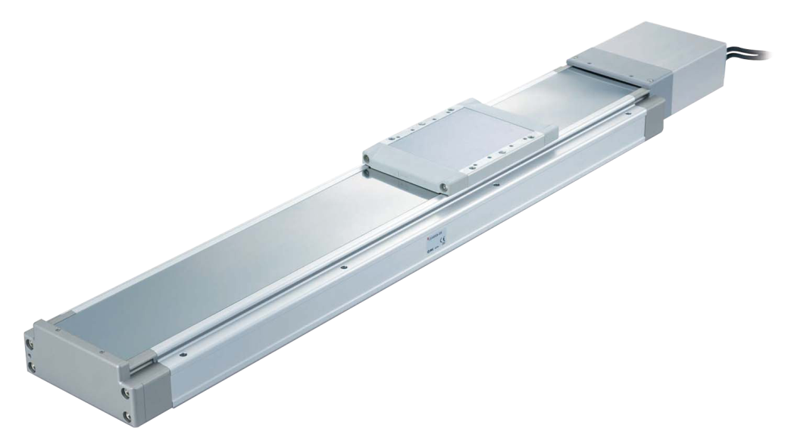

5) **SMC unlocks the performance of it's 'AS' speed controller**

The world’s leading pneumatics provider, has unlocked the performance of its AS Series speed controller with one touch fitting by giving it an upgrade. The latest AS Series has many enhanced features that support SMC’s focus to improve the performance and functionality of its products, as well as to develop innovations that deliver competitive advantages for its customers. Now easier to lock and unlock thanks to its push-lock mechanism, the AS Series is simpler to adjust thanks to a larger handle, both of which reduce overall labor time. Other labour saving features have been achieved by simplifying the maintenance and assembly of the AS Series by reducing the force required to insert and remove the tubes (up to 30% less for insertion and up to 20% less for removal) and by placing the tube connection in a higher position. Other modifications to the AS Series include the introduction of colour product identification, which minimises the risk of errors. Improved design flexibility is also a feature of the new AS series with a broader portfolio of tube connections from Ø2 to Ø16mm. A reduction in height gives additional space savings, with PBT thermoplastic and electroless nickel plated body materials offering high resistance to corrosion and an attractive finish. Recognised as a global technology leader and recently voted for the third consecutive year as one of the world’s most innovative company by leading business magazine, Forbes, SMC has a diverse customer base covering all automation industries. For more information about the AS Series, please visit www.smcin.com.

